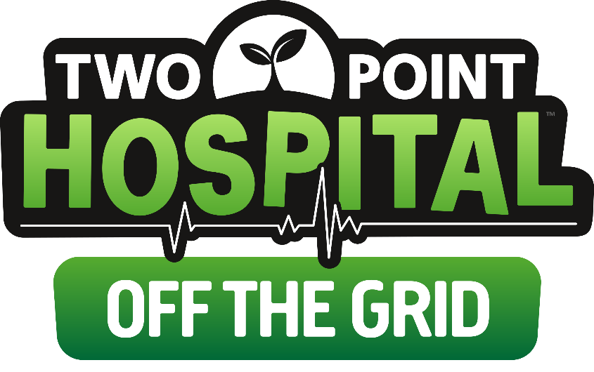

**Release of Two Point Hospital: Off the Grid delayed by one week, until 25 March 2020**

Two Point Hospital: Off The Grid sees PC players tackle new Green challenges, explore new exciting regions and cure more unusual illnesses, but fans will have to wait just a little while longer, as the release of Off The Grid and the ‘Exhibition Items Pack’ both move to Wednesday 25 March 2020. Two Point Studios ran into some unexpected issues while finalising Off the Grid, which means they will need a couple more days to ensure PC players can enjoy this new expansion to the fullest. The 10% early adopter discount will be extended until 1 April 2020 for anyone who purchases Two Point Hospital: Off the Grid from the 25 March 2020. For more information about the delay head over to Two Point Hospital’s blog [here](https://www.twopointstudios.com/two-point-hospital-off-the-grid-release-date).